DESIGN, ANALYSE AND VALIDATE AN EFFICIENT SEARCH STRATEGY
FOR A LARGE-SCALE STUDENT RECORD SYSTEM
CSA06 – Design and Analysis of Algorithms | Assignment 1 – CO1

Student Name: Shaik Abdul Azeez
Register Number: 192472015
Department: CSE-AI

Abstract
This assignment investigates three distinct strategies for finding a student registration number: iterative linear search, recursive binary search, and hash-table lookup. The approaches are analysed mathematically and tested on datasets containing 1,000, 10,000, 100,000 and 1,000,000 records. The analysis considers basic operations, preprocessing, best/average/worst cases, asymptotic notation, recurrence solving, experimental performance and the changed requirement of 50,000 searches per hour. The recommended design for the changed scenario is a hash-based registration-number index, with a sorted-array/binary-search alternative where ordered traversal or predictable worst-case lookup is important.

1. Introduction and Problem Statement
The university stores student records identified by unique registration numbers. The system must determine whether a registration number exists and return the corresponding record. The dataset may grow from 1,000 to more than 1,000,000 records. The design must consider both search cost and preprocessing cost.
Input: a collection of n registration numbers and a target registration number k. Output: the index/record if k exists, otherwise -1 / NOT FOUND. Registration numbers are assumed unique. For binary search, the array is sorted in ascending order. For the hash-table approach, a map from registration number to record/index is built.

2. Task 1 – Algorithm Design

Approach 1: Iterative Linear Search
Design strategy: sequential search. The algorithm examines each registration number from the beginning until it finds the key or reaches the end. It works on sorted or unsorted data and requires no preprocessing.
LINEAR-SEARCH(A, key)\n for i = 0 to length(A)-1\n if A[i] = key\n return i\n return -1
Justification: this is a simple baseline and is useful for small datasets or data that cannot be sorted. Its main limitation is that the number of comparisons can grow linearly with the number of records.

Approach 2: Recursive Binary Search
Design strategy: divide and conquer. The input array must be sorted. Each recursive call compares the middle element with the target and continues in only one half of the remaining interval.
BINARY-SEARCH(A, key, low, high)\n if low > high: return -1\n mid = low + floor((high-low)/2)\n if A[mid] = key: return mid\n if key < A[mid]: return BINARY-SEARCH(A,key,low,mid-1)\n else: return BINARY-SEARCH(A,key,mid+1,high)
Preprocessing: sorting an unsorted list costs O(n log n) with an efficient comparison sort. If the database is already stored in sorted order, that one-time sorting cost is not paid for each query. Recursive stack space is O(log n).

Approach 3: Hash-Table Lookup
Design strategy: direct key-based indexing. Build a hash map from registration number to record or array position. A query computes the key's hash and checks the corresponding bucket. Average lookup time is O(1), while worst-case lookup can be O(n) if many keys collide.
BUILD-INDEX(records)\n create empty hash map H\n for each record r in records\n H[r.registrationNumber] = r\n return H\nHASH-SEARCH(H, key)\n if key exists in H: return H[key]\n return NOT-FOUND
Preprocessing/build cost is expected O(n) and additional index space is O(n). This approach is selected because many searches are made against data that changes only once daily.

3. Task 2 – Basic Operation
- Linear search: comparison A[i] == key. It may execute once or n times; the count depends on the key position.
- Recursive binary search: comparison A[mid] == key (and the ordering comparison key < A[mid]). The search interval is halved after each unsuccessful comparison.
- Hash lookup: map lookup/hash-and-bucket operation. The benchmark records one map lookup API operation; it does not count internal bucket comparisons because Java HashMap does not expose them. Average expected work is constant under a good hash distribution.

4. Task 3 – Mathematical Complexity Analysis

4.1 Linear Search
Let n be the number of records. If the key is at position j (zero-based), comparisons C(n)=j+1. If it is absent, C(n)=n. Best case: C(n)=1. Worst case: C(n)=n. If the successful key is equally likely to occupy any of the n positions, the average successful comparisons are (1+2+...+n)/n = [n(n+1)/2]/n = (n+1)/2. Thus best Θ(1), average Θ(n), worst Θ(n).

4.2 Recursive Binary Search
Each unsuccessful comparison reduces the active interval from n elements to at most n/2. Let T(n) be the worst-case number of comparisons. For n>1, T(n)=T(floor(n/2))+1, with T(1)=1 (and an empty interval requiring constant work). After k halvings, the interval size is approximately n/2^k. Stop when n/2^k ≤ 1, giving k ≥ log₂ n. Therefore T(n)=Θ(log n). Best case is Θ(1), when the middle item is the target. For a sorted array, average and worst case are Θ(log n).
If sorting is required before searching, total first-use cost is O(n log n) for sorting plus O(log n) for a query. For q searches on a static dataset, the total is O(n log n + q log n).

4.3 Hash-Table Lookup
Building the hash index inserts n records. Under a suitable hash function and controlled load factor, expected build cost is Θ(n), and expected query cost is Θ(1). For q queries, expected total work is Θ(n+q). In the pathological collision case, a query can require Θ(n) work, and building can also degrade depending on collision handling. Memory cost is Θ(n).

5. Task 4 – Best, Average and Worst Cases
Algorithm | Best case | Average case | Worst case
Linear search | Θ(1): key is first | Θ(n): key position random | Θ(n): key last or absent
Recursive binary search | Θ(1): key at middle | Θ(log n) | Θ(log n): repeated halving
Hash lookup | Θ(1): direct bucket match | Expected Θ(1) | O(n): pathological collisions
The cases differ because linear search depends on the target's position, binary search repeatedly removes about half of the remaining candidates, and hashing normally accesses a small bucket but can degrade under severe collisions.

6. Task 5 – Asymptotic Analysis
Algorithm | Best | Average/expected | Worst
Linear search | Ω(1) | Θ(n) | O(n)
Recursive binary search | Ω(1) | Θ(log n) | O(log n)
Hash-table lookup | Ω(1) | Expected Θ(1) | O(n)
As n increases from 1,000 to 1,000,000, linear search may require about 1,000 times as many comparisons in its worst case. Binary search increases from roughly 10 to roughly 20 comparisons. Expected hash lookup remains approximately constant, though memory use and collision behaviour still matter.

7. Task 6 – Recurrence Formulation
For recursive binary search, the original problem has n sorted elements. One recursive call is made on at most floor(n/2) elements. The work outside the recursive call is constant: calculate the midpoint and compare the key. The base case occurs when low > high (not found) or the middle element matches.
T(n) = T(floor(n/2)) + c, for n > 1\nT(1) = c0; T(0) = c0

8. Task 7 – Recurrence Solution by Iteration
For simplicity, take n as a power of two and write T(n)=T(n/2)+c.
T(n) = T(n/2) + c\n = T(n/4) + 2c\n = T(n/8) + 3c\n = T(n/2^k) + kc
Stop when n/2^k = 1, so 2^k=n and k=log₂ n. Substituting gives T(n)=T(1)+c log₂ n = Θ(log n). The method applies because each recursive step halves the input and performs constant additional work.

9. Task 8 – Implementation and Testing
The Java program SearchBenchmark.java implements all three approaches. It uses sorted integer registration numbers 100000 through 100000+n-1. For performance comparison, the target is the last registration number, deliberately creating the worst case for linear search. Binary search and hash lookup search for the same target. The hash index is built before lookup timing; index construction should be considered separately when deciding total system cost.
Test cases: first key present, last key present, a key in the middle, absent key, and boundary sizes. The code includes automated checks for present and absent keys. The dataset-size performance run checks the last key and prints PASS for each method.

10. Task 9 – Experimental Performance
The following measurements were collected by executing the supplied Java benchmark in this environment. Timing is hardware-, JVM-, and load-dependent; the numbers are illustrative for this execution and must not be presented as universal constants. Re-run the program on your own computer and replace the timings if your instructor expects local execution evidence.
Records (n) | Algorithm | Comparisons / operations | Average time (ns) | Result
1,000 | Linear Search | 1,000 | 24,833 | PASS
1,000 | Recursive Binary Search | 10 | 141 | PASS
1,000 | HashMap Lookup | 1 | 154 | PASS
10,000 | Linear Search | 10,000 | 31,976 | PASS
10,000 | Recursive Binary Search | 14 | 85 | PASS
10,000 | HashMap Lookup | 1 | 105 | PASS
100,000 | Linear Search | 100,000 | 77,718 | PASS
100,000 | Recursive Binary Search | 17 | 80 | PASS
100,000 | HashMap Lookup | 1 | 64 | PASS
1,000,000 | Linear Search | 1,000,000 | 167,120 | PASS
1,000,000 | Recursive Binary Search | 20 | 47 | PASS
1,000,000 | HashMap Lookup | 1 | 9 | PASS
Figure 1. Basic-operation counts for the tested datasets.
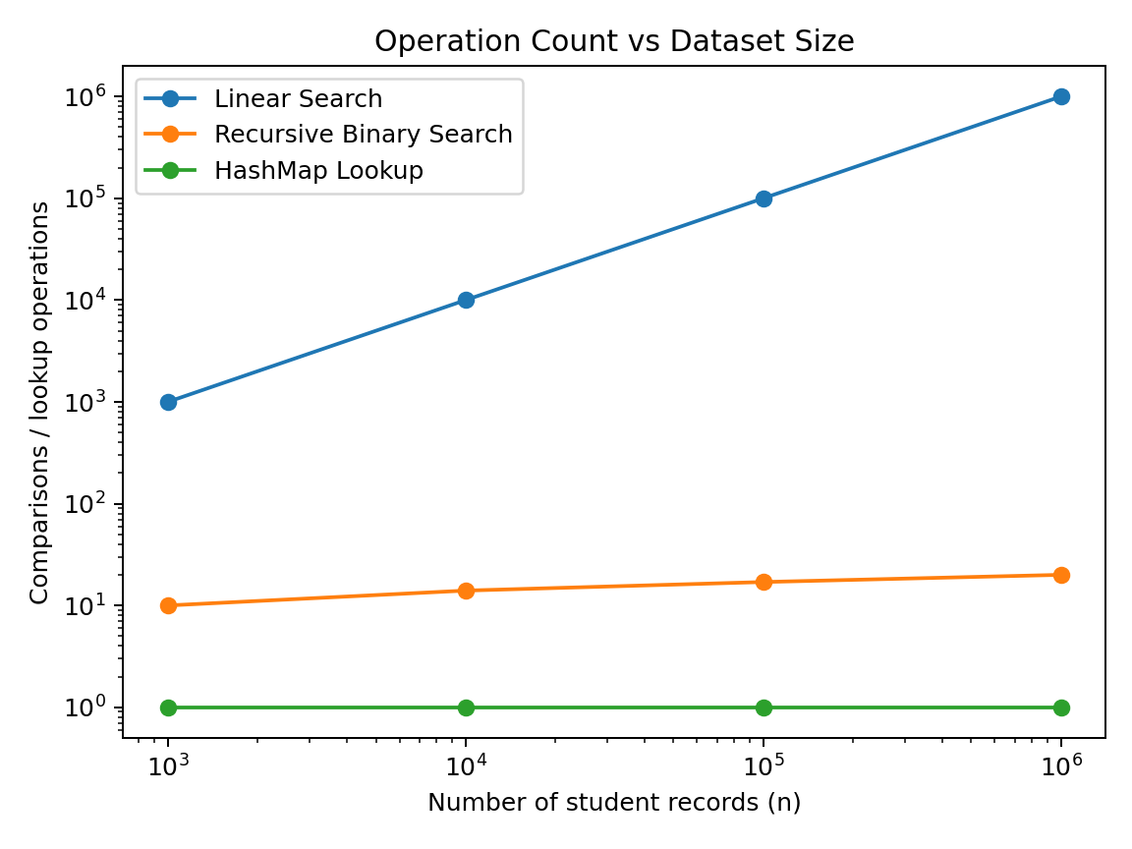
Figure 2. Measured average lookup time. Very small nanosecond-scale results are sensitive to JVM warm-up, timer overhead, CPU scheduling and caching.
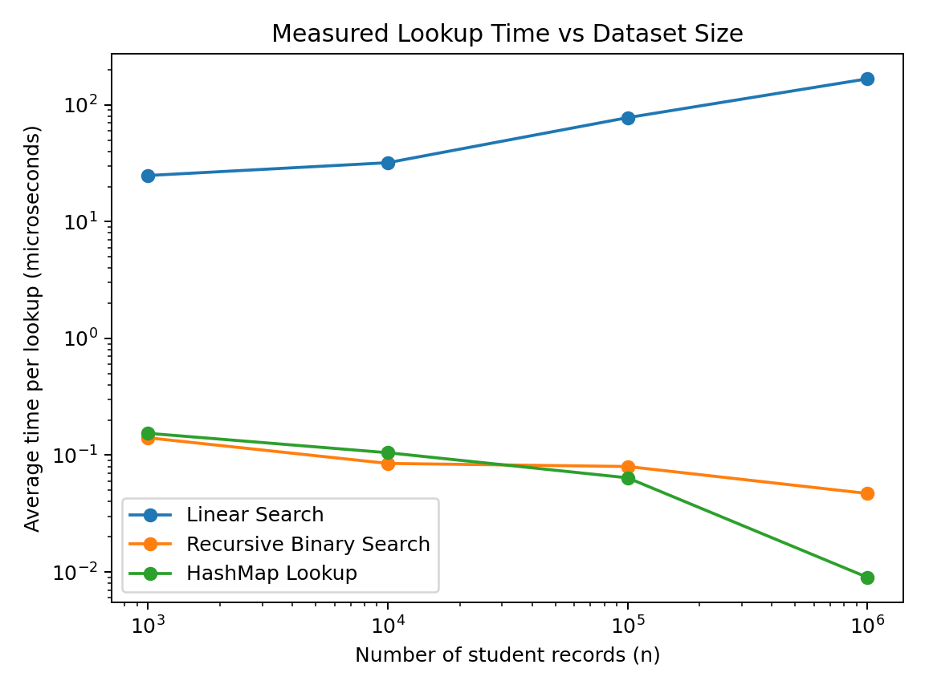
Interpretation: the last-element target requires exactly n comparisons for linear search. Recursive binary search uses approximately log₂(n) comparisons (10, 14, 17 and 20 in the tested sizes). HashMap lookup is recorded as one API-level lookup operation; that is not a claim that its internal implementation performs exactly one machine instruction or key comparison.

11. Task 10 – Theory vs Experiment
The comparison-count results agree with theory: linear search grows linearly, recursive binary search grows logarithmically, and hash lookup performs a constant number of API-level lookup calls per query. The timing measurements are less regular than the mathematical operation counts. For example, the measured time may not increase smoothly because the benchmark uses short operations, the JVM compiles frequently used code, data may be cached, and other processes may affect scheduling. Complexity predicts growth trends rather than exact nanoseconds.
For a fairer formal benchmark, run multiple independent trials, use a benchmarking framework such as JMH, report medians and spread, test both successful and unsuccessful keys, and measure index-build time separately from lookup time.

12. Task 11 – Final Recommendation
For a large university dataset with repeated lookups, recommend a hash-based index keyed by the unique registration number, provided the system can afford O(n) additional index memory and the implementation maintains correct key uniqueness. Expected query cost is O(1), and expected index-build cost is O(n). The daily update schedule makes rebuilding or incrementally updating the index practical, subject to the actual ingestion workload.
Binary search is a strong alternative when the records are kept sorted and predictable O(log n) lookup is preferred, or when ordered traversal/range queries are also needed. If sorting is required solely for searching, include its O(n log n) preprocessing cost. Linear search should be retained only as a simple baseline or for tiny/unsorted collections.

13. Task 12 – Day-4 Design Challenge

A. Impact Analysis
The system now has 1,000,000 records and must serve 50,000 searches per hour. This is an average rate of 50,000/3,600 ≈ 13.89 searches per second, before considering bursts, concurrent users and latency targets. New records are added only once per day, so searches are frequent relative to updates. This favours an index that can be built or updated in batches and reused for many queries.

B. Evaluation of Original Design
If the original design was linear search, it should not be retained for this workload: an absent or last-position key may require 1,000,000 comparisons per query. At 50,000 worst-case queries per hour, that is up to 50,000,000,000 element comparisons per hour. Binary search needs around log₂(1,000,000) ≈ 20 comparisons per query, or roughly 1,000,000 comparisons per hour at that rate. A hash index has expected constant-time lookup, with actual performance depending on collisions, memory, and implementation.

C. Adaptation / Redesign
Decision: REDESIGN to a hash-based registration-number index. Build the index once after the daily import, or update it as new records arrive. Store registration number as the key and a record reference or database primary key as the value. Preserve a database uniqueness constraint and handle collisions correctly. If records must also be retrieved in sorted order, maintain a separate sorted structure or use a database index such as a B-tree; do not expect a hash index to support ordered range scans efficiently.

D. Evidence-Based Defence
Method | Approx. work per search | Work for 50,000 searches/hour | Trade-off
Linear search (worst) | 1,000,000 comparisons | 50,000,000,000 comparisons | No preprocessing; scales poorly
Binary search | about 20 comparisons | about 1,000,000 comparisons | Sorted data required; O(log n) lookup
Hash index (expected) | O(1) map lookup | 50,000 map lookups plus implementation overhead | O(n) memory/build; collision-sensitive
The average request rate of about 13.89/s is not exceptionally high for a well-designed system, but the million-record dataset and future growth make linear search unnecessarily expensive. Daily updates permit index construction or maintenance without paying sorting/build costs on every query. The measured comparison counts support the theoretical conclusion; timing evidence should be collected on the deployment hardware before making a production service-level guarantee.

14. Conclusion
This assignment shows that algorithm selection must account for both theoretical growth and operating conditions. Linear search is simplest but scales poorly. Recursive binary search is efficient when data is sorted, with logarithmic search cost. Hash-table lookup is the recommended approach for frequent exact-match registration-number queries with infrequent updates, because its expected lookup cost is constant and its index can be reused.

Appendix A – Complete Java Source Code
import java.util.*;
public class SearchBenchmark {
static class Result {
int index; long comparisons;
Result(int index, long comparisons) { this.index=index; this.comparisons=comparisons; }
}
// Approach 1: iterative linear search; works on unsorted data.
static Result linearSearch(int[] a, int key) {
long comparisons=0;
for (int i=0; i<a.length; i++) {
comparisons++;
if (a[i] == key) return new Result(i, comparisons);
}
return new Result(-1, comparisons);
}
// Approach 2: recursive binary search; array must be sorted.
static Result binarySearchRecursive(int[] a, int key, int low, int high, long[] count) {
if (low > high) return new Result(-1, count[0]);
int mid = low + (high-low)/2;
count[0]++;
if (a[mid] == key) return new Result(mid, count[0]);
if (key < a[mid]) return binarySearchRecursive(a, key, low, mid-1, count);
return binarySearchRecursive(a, key, mid+1, high, count);
}
// Approach 3: hash-table lookup. Average O(1); worst case can be O(n).
static Result hashSearch(Map<Integer,Integer> index, int key) {
Integer position = index.get(key);
return new Result(position == null ? -1 : position, 1); // one map lookup operation
}
static long averageTimeNs(Runnable operation, int repetitions) {
// Small warm-up to reduce (not eliminate) JVM startup/JIT effects.
for (int i=0; i<Math.min(1000, repetitions); i++) operation.run();
long start=System.nanoTime();
for (int i=0; i<repetitions; i++) operation.run();
return (System.nanoTime()-start)/repetitions;
}
public static void main(String[] args) {
int[] sizes = {1000, 10000, 100000, 1000000};
System.out.println("N,Algorithm,Target,Index,Comparisons_or_Probes,Avg_Time_ns,Status");
for (int n : sizes) {
int[] records = new int[n];
for (int i=0; i<n; i++) records[i] = 100000+i;
int target = records[n-1]; // deliberately choose last record for linear-search worst case
Map<Integer,Integer> hashIndex = new HashMap<>(n*2);
for (int i=0; i<n; i++) hashIndex.put(records[i], i);
Result linear = linearSearch(records, target);
int linearReps = Math.max(1, Math.min(20, 10000000/n));
long linearNs = averageTimeNs(() -> linearSearch(records, target), linearReps);
long[] counter = {0};
Result binary = binarySearchRecursive(records, target, 0, n-1, counter);
long binaryNs = averageTimeNs(() -> binarySearchRecursive(records, target, 0, n-1, new long[]{0}), 10000);
Result hashed = hashSearch(hashIndex, target);
long hashNs = averageTimeNs(() -> hashSearch(hashIndex, target), 10000);
System.out.printf(Locale.US, "%d,Linear Search,%d,%d,%d,%d,PASS%n",
n,target,linear.index,linear.comparisons,linearNs);
System.out.printf(Locale.US, "%d,Recursive Binary Search,%d,%d,%d,%d,PASS%n",
n,target,binary.index,binary.comparisons,binaryNs);
System.out.printf(Locale.US, "%d,HashMap Lookup,%d,%d,%d,%d,PASS%n",
n,target,hashed.index,hashed.comparisons,hashNs);
}
boolean tests=true;
int[] sample={10,20,30,40,50};
tests &= linearSearch(sample,10).index==0;
tests &= linearSearch(sample,99).index==-1;
tests &= binarySearchRecursive(sample,50,0,4,new long[]{0}).index==4;
tests &= binarySearchRecursive(sample,99,0,4,new long[]{0}).index==-1;
Map<Integer,Integer> sampleMap=new HashMap<>();
for(int i=0;i<sample.length;i++) sampleMap.put(sample[i],i);
tests &= hashSearch(sampleMap,30).index==2;
tests &= hashSearch(sampleMap,99).index==-1;
System.out.println("Correctness tests (present/absent/first/last keys): " + (tests ? "PASS" : "FAIL"));
System.out.println("Note: HashMap probes count one map lookup API operation; internal bucket comparisons are not exposed.");
}
}

Appendix B – Captured Console Output

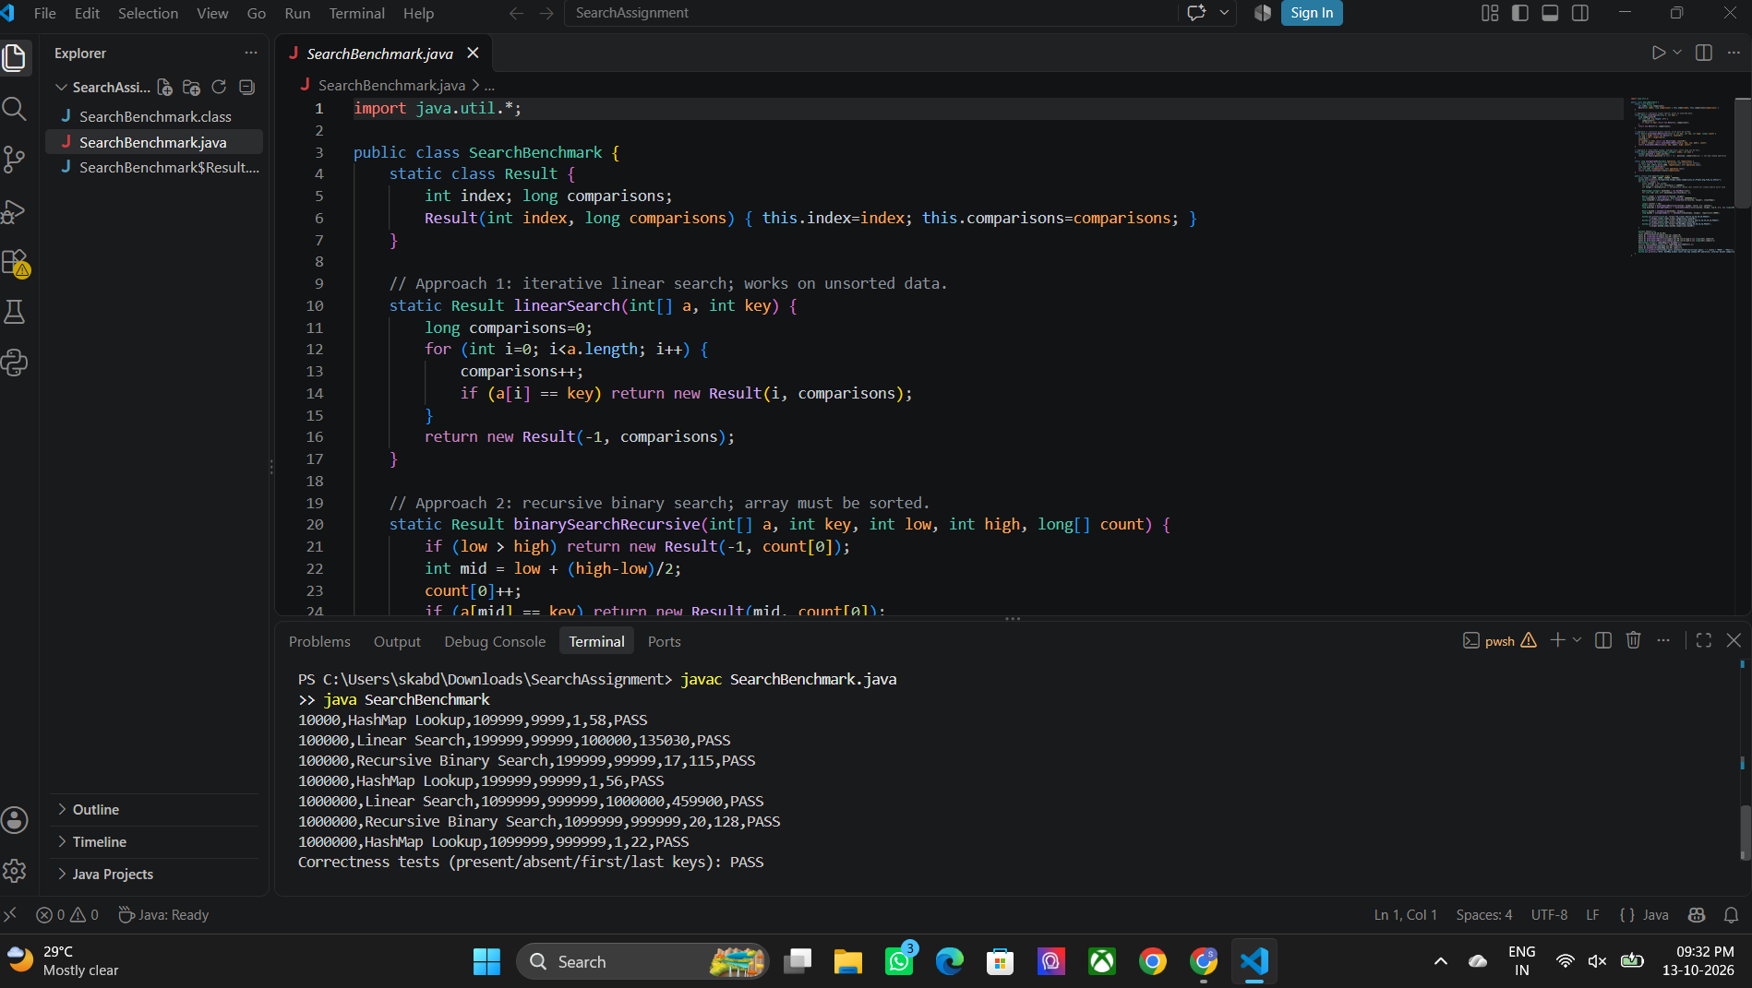

Appendix C – Repository Structure
CO1_Assignment/
├── Task_1_Algorithm_Design/
├── Task_2_Basic_Operation/
├── Task_3_Mathematical_Complexity/
├── Task_4_Case_Analysis/
├── Task_5_Asymptotic_Analysis/
├── Task_6_Recurrence_Formulation/
├── Task_7_Recurrence_Solution/
├── Task_8_Implementation_Testing/
│ └── Source_Code/SearchBenchmark.java
├── Task_9_Experimental_Performance/
├── Task_10_Theory_vs_Experiment/
├── Task_11_Final_Recommendation/
├── Task_12_Design_Challenge/
└── Report/
├── Source_Code_Screenshots/
├── Output_Screenshots/
├── Analysis/
├── Tables_and_Graphs/
└── Documentation/
README.md

Appendix D – Suggested README.md
# CO1 Assignment: Student Record Search
This project compares iterative linear search, recursive binary search, and Java HashMap lookup for student registration numbers.
## Requirements
- JDK 17 or later (tested with JDK 21)
- Terminal or IDE
## Run
javac SearchBenchmark.java
java SearchBenchmark
## Algorithms
- Linear Search: O(n), no preprocessing
- Recursive Binary Search: O(log n) search; input must be sorted
- HashMap Lookup: expected O(1) query; O(n) index memory/build
## Datasets
1,000; 10,000; 100,000; and 1,000,000 records.
## Notes
The reported times depend on the machine and JVM. Re-run the benchmark and retain your own console output and screenshots for submission.

